CEO approval: |  | Date:
LGB Cluster ratification |  | Date:
Last reviewed on: |  | December 2021
Next review due by: |  | December 2022
Academy Policy

Ambleside Academy Admissions Policy 2023/24

Contents

Introduction 3
How to apply 3
Requests for admission outside the normal age group 3
Applications for places in Reception Year 2023/24 4
Late applications in Reception Year 2023/24 4
Admission number 5
Oversubscription criteria 5
Tie break 5
Challenging behaviour 6
Fair access Protocol 6
Withdrawing an offer of a place 6
In-year admissions 6
Appeals 7
Definition of terms 7
Ambleside Academy catchment area 2023/24 8
Annex 1 9

Introduction
The school policy for Admission for the academic year 2023/2024 has been written to reflect Nottingham
City Local Authority guidance. This policy is reviewed on a yearly basis by Ambleside Academy and the
Raleigh Learning Trust.

This policy aims to:

• Explain how to apply for a place at the Academy
• Set out the Academy’s arrangements for allocating places to the pupils who apply
• Explain how to appeal against a decision not to offer your child a place

This policy is based on the following advice from the Department for Education (DfE):

• School Admissions Code
• School Admission Appeals Code

All references to ‘Academy’ in this document refer to Ambleside Academy.

How to apply
All applications for places should be made to the applicant’s home local authority. Parents/carers resident in Nottingham City are strongly encouraged to apply through the City Council’s website using the online admissions system. Alternatively, if parents/carers resident in Nottingham City wish to apply using a paper application form (School Common Application Form) this is available from and should be returned to the School Admissions Team, Access and Inclusion, LH Box 14, Loxley House, Station Street, Nottingham, NG2 3NG.

You will receive an offer for a school place directly from the local authority.

Please note, pupils already attending our nursery will not transfer automatically into the main school. A separate application must be made for a place in reception.

Requests for admission outside the normal age group
Parents are entitled to request a place for their child outside of their normal age group by contacting the child’s home local authority.

Decisions on requests for admission outside the normal age group will be made on the basis of the circumstances of each case and in the best interests of the child concerned. In accordance with the School Admissions Code, this will include taking account of:

- Parents’ views
- Information about the child’s academic, social and emotional development
- Where relevant, their medical history and the views of a medical professional
- Whether they have previously been educated out of their normal age group
- Whether they may naturally have fallen into a lower age group if it were not for being born prematurely
- The headteacher’s views

Wherever possible, requests for admission outside a child’s normal age group will be processed as part of the main admissions round. They will be considered on the basis of the admission arrangements laid out in this policy, including the oversubscription criteria.

Applications will not be treated as a lower priority if parents have made a request for a child to be admitted outside the normal age group.

Parents will always be informed of the reasons for any decision on the year group a child should be admitted to. Parents do not have a right to appeal if they are offered a place at the school but it is not in their preferred age group.

Applications for places in Reception Year 2023/24
For entrance to the academy in September 2023, application packs will be distributed by the local authority to parents/carers resident in Nottingham City by post, or via city nursery schools, by the 14 November 2022. The closing date for applications under the co-ordinated admission scheme is 15 January 2023. Offers of places will be made on the national offer date of 17 April 2023 (or next working day after this date). In respect of applications for the 2023 autumn term, for parents/carer who apply for a place online an email will be sent on the 17 April 2023. If a paper application was submitted via the Common Application Form, decisions will be posted on the 17 April 2023 and should be received by parent/carers on the 19 or 20 April 2023.

Parents/carers should confirm to the local authority whether they wish to accept the place offered within 14 days of receipt of the offer. Failure to do so will result in the place being withdrawn.

Late applications for Reception Year in 2023/24
Nottingham City Council and the Trust may be willing to accept applications which are received late, i.e. after the closing date of 15 January 2023, but before 5.00 p.m. on 9 February 2023 for good reason for example:

- a family returning from abroad
- a lone parent who has been ill for some time
- a family moving into Nottingham from another area
- other exceptional circumstances

Each case will be treated on its merits.

Any preferences received by Nottingham City Council up to 9 February 2023, with good reason for being late, and where appropriate, with the agreement of the Governing Body of the academy will be included in the first cycle of allocations and will be notified on the national offer day.

All other late applications for places at the academy received by Nottingham City Council after 9 February 2023 will be dealt with after the offer day.

Other local authorities might have different policies when dealing with late applications. Applicants are advised to contact their home local authority to find out what their policy is.

Admission number

Ambleside Academy has an agreed admission number of 90 pupils for entry in each year group.

Oversubscription criteria
All children whose education, health and care (EHC) plans name the school will be admitted before any other places are allocated.

If the Academy is not oversubscribed, all applicants will be offered a place.

In the event that the Academy receives more applications than the number of places it has available, places will be given to those children who meet any of the criteria set out below, in order until all places are filled.

- Places will first be allocated to a ‘looked after child’ or a child who was previously looked after, but immediately became subject to an adoption, child arrangement, or special guardianship order. A looked after child is a child is;

  - in the care of a local authority, or
  - being provided with accommodation by a local authority in the exercise of their social services functions in accordance with section 22(1) of the Children Act 1989 at the time of making an application to a school.

- Places will then be allocated to pupils, who at the closing date for applications, live within the catchment area of the academy, and who at the time of admission, have a brother or sister attending the academy who will still be on roll at the proposed date of admission.
- Places will then be allocated to children of staff, specifically teaching or support staff, on the payroll of Ambleside Academy at the time of admission, where the member of staff is recruited to fill a vacant post for which there is a demonstrable skill shortage.
- Places will then be allocated to other pupils, who at the closing date for applications, live within
the catchment area of the academy.
- Places will then be allocated to pupils who live outside the catchment area of the academy, and who at the time of admission, have a sibling attending the academy.
- Places will then be allocated to other pupils who live outside the catchment area of the academy.

Tie break
In the case of two or more applications that cannot be separated by the criteria outlined above, the Academy will use the distance between the Academy and a child’s home to decide between applicants. Priority will be given to children who live closest to the Academy. Distance will be measured in a straight line from the child’s home address to the Academy’s front gates on Minver Crescent. A child’s home address will be considered to be where he/she is resident for the majority of nights in a normal school week.

Where the distance between two children’s home and the school is the same, random allocation will be used to decide between them. This process will be independently verified.

Challenging behaviour

We will not refuse to admit a child on behavioral grounds in the normal admissions round or at any point in the normal year of entry. We may refuse admission in certain cases where the specific criteria listed in the School Admissions Code (paragraph 3.8-3.14) apply, i.e. where section 87 of the School Standards and Framework Act 1998 is engaged.

We may refuse admission for an in-year applicant for a year group that isn’t the normal point of entry, only in such a case that we have good reason to believe that the child may display challenging behaviour that may adversely affect the provision we can offer. In this case, we will refer these pupils to the Fair Access Protocol. We will not refuse admission on these grounds to looked after children, previously looked after children and children with EHC plans listing the school.

Fair Access Protocol
We participate in Nottingham City Council’s Fair Access Protocol. This helps ensure that all children, including those who are unplaced and vulnerable, or having difficulty in securing a school place in-year, get access to a school place as quickly as possible.

Withdrawing an offer of a place
Any offers of a place found to be made on the basis of inaccurate information can be withdrawn. Such examples would include fraudulent, or intentionally misleading applications (e.g. a false claim to residence in the catchment area of the academy).

Failure to accept a place offered at the academy within the 14 days previously specified may also lead to the withdrawal of that offer.

In-year admissions
Parents can apply for a place for their child at any time outside the normal admissions round. As is the case in the normal admissions round, all children whose EHC plans name the school will be admitted.
Children who are the subject of a direction by a Local Authority to admit, or who are allocated a place at the academy in accordance with the In-Year Fair Access Protocol, will take precedence over children on a waiting list.
Likewise, if there are spaces available in the year group you are applying for, your child will be offered a place.

If there are no spaces available at the time of your application, your child’s name will be added to a waiting list for the relevant year group. When a space becomes available, it will be filled by one of the pupils on the waiting list in accordance with the oversubscription criteria listed in this policy. Priority will not be given to children on the basis that they have been on the waiting list the longest.

Applications for in-year admissions should be completed through the City Council’s website using the online admissions system. Alternatively, if parents/carers resident in Nottingham City wish to apply using a paper application form (School Common Application Form) this is available from and should be returned to the School Admissions Team, Access and Inclusion, LH Box 14, Loxley House, Station Street, Nottingham, NG2 3NG.

Parents will be notified of the outcome of their in-year application in writing within 15 school days.

Appeals
If your child’s application for a place at the Academy is unsuccessful, you will be informed by why admission was refused and given information about the appeals process. Appeals can be submitted via e-form, using the link below.

https://www.nottinghamcity.gov.uk/information-for-residents/education-and-schools/school-admissions/admission-appeals/

Definition of terms

Residence

A child’s home address will be considered to be where he/she is resident for the majority of nights in a normal school week. If more than one person has parental responsibility for the child, and those people live in separate homes, the academy will consider the child’s home address to be the property at which they live for most of the week (this includes weekends as well as weekdays).

If the child lives at two separate homes for an equal length of time, the child’s permanent place of residence will be taken as the address shown on the child benefit award notice.

Brothers or sisters – sibling connection

- For admission purposes the academy considers the following as siblings:

- a brother or sister who share the same parents;
- a half brother or half sister, where two children share one common parent;
- a step brother or step sister, where two children are related by a parent’s marriage or civil partnership.
- adopted or fostered children living in the same household under the terms of a child arrangement or special guardianship order.

- Where applications are received in respect of twins, triplets or children of other multiple births, the academy will endeavour to offer places in the same school, admitting above the planned admission number where necessary. If this is not possible, the parent/carer will be asked which child(ren) should take up the place(s). The parent/carer will still have a right of appeal against a refusal of a place.

Catchment area

The defined catchment area for the academy is set out on the next page.

RLT Trust Equality Statement

Accessibility of policy documents

Parents and carers are welcome to ask for further information about any policy matter. Copies of our policies are displayed on the Academy website www.amblesideprimaryschool.co.uk and be requested via the Academy Office. The Academy will try to arrange for the translation or summary of a document when this is requested by a parent or carer whose first language is not English.

Ambleside Academy catchment area 2023/24
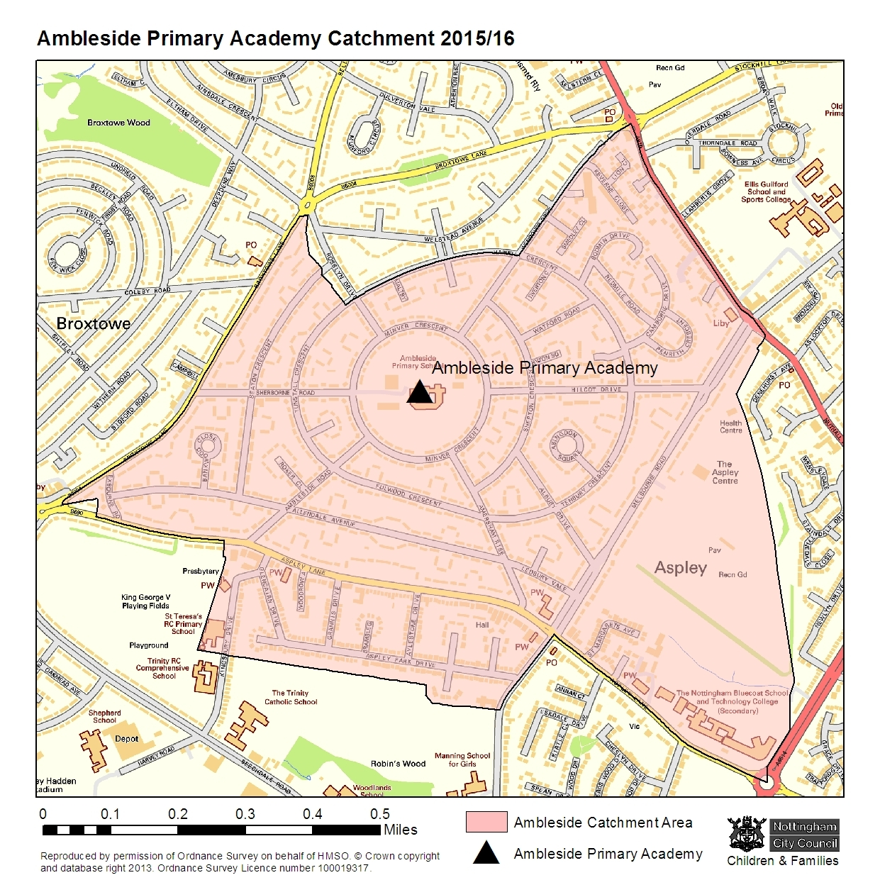

ANNEX 1
TIMETABLE FOR CO-ORDINATED ADMISSION ARRANGEMENTS 2023/24
(ADMISSION TO INFANT, PRIMARY AND JUNIOR SCHOOLS)

By 14 November 2022
Information distributed by the local authority to Nottingham City parents and carers or via nursery schools where the child attends a nursery attached to a city infant or primary school.
↓
By 15 January 2023
Closing date for receipt of Common Application Form (CAF).
↓
By 6 February 2023
Nottingham City Council sends applications to other local authorities for schools in their area.
↓
By 20 February 2023
Nottingham City Council sends applications for primary school places to schools which are their own admission authority (listed in Note 1 at bottom of page)
↓
By 3 March 2023
Own admission authority schools listed in Note 1 to send to Nottingham City Council a list of children who can be offered a place and those who cannot (all applications to be ranked).
↓
By 10 March 2023
Nottingham City Council to determine which provisional offers will be made at Nottingham City schools taking account of the ranking of the preferences on SCAFs and inform Nottinghamshire County Council, other local authorities and other admission authorities of those provisional offers which are to be accepted and of those which are not to be accepted.
↓
By 3 April 2023
Inform Nottinghamshire County Council, other local authorities and other admission authorities of which offers are to be confirmed for places in their primary schools and those which are not.
↓
On 17 April 2023
Offers posted to parents/carers resident in Nottingham City, including offers on behalf of academies, voluntary aided academies and Nottinghamshire County Council. Emails sent on16 April 2020 to Nottingham City parents and carers who applied online.
↓
Within 14 days
Parents/carers required to confirm acceptance of place offered.

Note 1 – own admission authority primary schools/academies in Nottingham City:
Ambleside Academy, Blessed Robert Widmerpool Catholic, Blue Bell Hill, Bluecoat Primary, Brocklewood, Bulwell St Mary’s CE, Burford,Djanogly Northgate, Djanogly Sherwood, Djanogly Strelley, Edale Rise, Edna G Olds, Firbeck, Glapton, Glenbrook, Highbank,Hogarth, Huntingdon, Jubilee L.E.A.D., Milford, Nottingham Academy, Old Basford, Our Lady and St. Edward Catholic, OurLady of Perpetual Succour Catholic, Portland Spencer,Radford, Robert Shaw, Rosslyn Park, Scotholme, Sneinton St.Stephen’s CofE, Southwark, SouthWilford Endowed CofE, Springfield, St Ann’s Well, St. Augustine’s Catholic, St. Margaret
Clitherow Catholic, St. Mary’s Catholic, St. Patrick’s Catholic, St. Teresa’s Catholic, Stanstead, Sycamore, Victoria, Warren,Whitegate, Whitemoor, William Booth and Windmill L.E.A.D.

